Service是Android提供一个允许长时间留驻后台的一个组件

**Service的生命周期图**

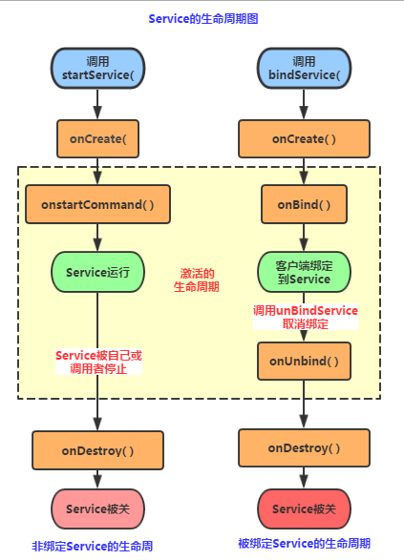

**新建Service示例**

**新建TestService1.java**

package com.example.myapplication;  
  
import android.app.Service;  
import android.content.Intent;  
import android.os.IBinder;  
import android.util.Log;  
  
public class TestService1 extends Service {  
 private final String TAG = "TestService1";  
 //必须要实现的方法  
 @Override  
 public IBinder onBind(Intent intent) {  
 Log.*i*(TAG, "onBind方法被调用!");  
 return null;  
 }  
  
 //Service被创建时调用  
 @Override  
 public void onCreate() {  
 Log.*i*(TAG, "onCreate方法被调用!");  
 super.onCreate();  
 }  
  
 //Service被启动时调用  
 @Override  
 public int onStartCommand(Intent intent, int flags, int startId) {  
 Log.*i*(TAG, "onStartCommand方法被调用!");  
 return super.onStartCommand(intent, flags, startId);  
 }  
  
 //Service被关闭之前回调  
 @Override  
 public void onDestroy() {  
 Log.*i*(TAG, "onDestory方法被调用!");  
 super.onDestroy();  
 }  
}

**在AndroidManifest.xml注册Service**

<?xml version="1.0" encoding="utf-8"?>  
<manifest xmlns:android="http://schemas.android.com/apk/res/android"  
 package="com.example.myapplication">  
  
 <application  
 android:allowBackup="true"  
 android:icon="@mipmap/ic_launcher"  
 android:label="@string/app_name"  
 android:roundIcon="@mipmap/ic_launcher_round"  
 android:supportsRtl="true"  
 android:theme="@style/AppTheme">  
  
 <!--使用的类-->  
 <service android:name=".TestService1">  
 <intent-filter>  
 <!--动作名称-->  
 <action android:name="TEST_SERVICE1"/>  
 </intent-filter>  
 </service>  
 </application>  
  
</manifest>

**在Activity中启动service**

public class MainActivity extends AppCompatActivity {  
  
 @Override  
 protected void onCreate(Bundle savedInstanceState) {  
 super.onCreate(savedInstanceState);  
 setContentView(R.layout.*activity_main*);  
  
 Button start = (Button) findViewById(R.id.*start*);  
 Button stop = (Button) findViewById(R.id.*stop*);  
 //创建启动Service的Intent,以及Intent属性  
 final Intent intent = new Intent();  
 intent.setAction("TEST_SERVICE1");  
 intent.setPackage("com.example.myapplication");//Service所在应用的包名  
 //为两个按钮设置点击事件,分别是启动与停止service  
 start.setOnClickListener(new View.OnClickListener() {  
 @Override  
 public void onClick(View v) {  
 // 启动 service  
 startService(intent);  
 }  
 });  
  
 stop.setOnClickListener(new View.OnClickListener() {  
 @Override  
 public void onClick(View v) {  
 // 关闭 service  
 stopService(intent);  
 }  
 });  
 }  
}